* **Name of the Activity:** International Webinar on "Artificial Intelligence: Emerging Trends of Technology and Its impact on Business Studies, Employment."
* **Type of the Activity:** Webinar
* **Organizing Department:** Career Counselling Cell, Chakdaha College and the Institute of Chartered Accountants of India (ICAI)
* **Date and time of the Activity:** 27.09.2020 from 18.30 pm – 21.30 pm
* **Link of the Activity:** <https://youtu.be/55XmQByDIpw>
* **Speakers:**
  + Prof. Dr. Tuhin Mukherjee, Assistant Professor, Department of Business Administration, K.U.
  + Dr. Indranil Ghosh Ray, P.D. Research Fellow, Department of Computer Science, University of Warwick, U.K.
  + Prof. Dr. Sayantan Kundu, Assistant Professor, Accounting & Finance, IIM, Ranchi
* **Outcome:** During the pandemic period, Department of Commerce and IQAC, Chakdaha College organized an international level webinar on the topic: “Artificial Intelligence: Emerging Trends of Technology and its Impact on Business Studies, Employment.” With the Principal of Chakdaha College, Dr. Swagata Das Mohanta, as the patron of the webinar, its chief guest was Prof. (Dr.) Saikat Mitra, Honourable Vice-Chancellor of MAKAUT, West Bengal. The other invited speakers were Prof. Dr. Tuhin Mukherjee, Assistant Professor, Dept. of Business Administration, University of Kalyani, West Bengal, India, Dr. Indranil Ghosh Ray, P.D. Research Fellow, Dept. of Computer Science, University of Warwick, U.K. and Prof. Dr. Sayantan Kundu, Assistant Professor, Accounting and Finance, IIM, Ranchi, Kolkata, India. All of the invited honorable speakers gave valuable talks in the webinar. The webinar was set about by the patron, Dr. Swagata Das Mohanta, with her welcome address. Then Prof. (Dr.) Saikat Mitra delivered an inaugural speech. After that the invited speakers gave their valuable talks. Dr. Indranil Ghosh Ray emphasized on the technology associated with the quickly emerging Artificial Intelligence while the other two speakers, Prof. (Dr.) Tuhin Mukherjee and Prof. (Dr.) Sayantan Kundu gave their talks majorly on the impacts of AI in the business sector and employment. After that an interactive Q & A session was also held, where the attendees were able to ask their questions related to the topic. To wrap the event up, a final vote of thanks was held at the end. Overall, the international webinar organized by Chakdaha College got very vigorous and applauding feedback.
* **Photograph of the Programme:**

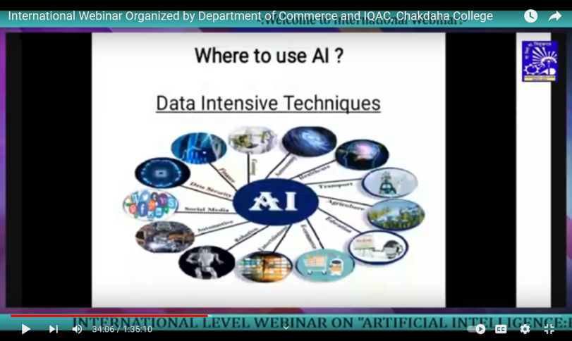 Number of Views: 637